ZAMBIAN MINERALS AGAINST POVERTY (ZAMAP)

“Zambian Gold - Empowering Communities, Feeding the Nation, Building Prosperity for All.”

FOREWORD


A Joint Message from Evans Lukomona - CEO & Founder, CDT Group Germany
and Maria Branchetti - Deputy CEO

Welcome to a new chapter in Zambia’s story.
At a time when many have wondered how the nation’s vast mineral wealth can truly benefit its people, ZAMAP stands as a bold and practical answer. Today, we say to the youth, to the chiefdoms, and to every Zambian community: do not worry—the solution has arrived.
Zambia is richly blessed. Beneath our soil lies not only gold and precious minerals, but also opportunity, dignity, and the promise of a better future. Through ZAMAP, we are committed to ensuring that this wealth no longer passes by our people—but uplifts them.
To our young people: your time is now.
To our chiefdoms: your role is central and respected.
To our communities: you are the true stakeholders of this land.
To our valued international investors and partners - both present and future - we extend a hand of cooperation. Zambia is open for responsible, transparent, and mutually beneficial partnerships. However, we emphasize: sustainable success must include the people of Zambia. Together, we can build prosperity that is shared, lawful, and lasting.
Let us work hand in hand to eliminate poverty, create opportunity, and transform Zambia into a beacon of inclusive development.
Welcome to ZAMAP—where minerals meet humanity.

ABOUT ZAMAP
Zambian Minerals Against Poverty (ZAMAP) is a strategic department of CDT Group Germany dedicated to promoting community participation, empowerment, and ownership in Zambia’s mineral wealth across all ten provinces.
ZAMAP bridges the gap between:
- Local communities and mineral resources
- Youth and economic opportunity
- Investors and sustainable partnerships
Our mission is simple yet powerful:
To turn Zambia’s natural resources into tools for eliminating poverty and building national prosperity.

BRIEF BACKGROUND
Between the 1960s and early 1990s, Zambia’s economy thrived largely on copper mining, especially in the Copperbelt Province. During this period, the nation experienced strong economic growth, and many citizens benefited directly and indirectly from the mining sector.
However, in the late 1990s, the privatization of mines shifted control to foreign investors. While investment increased, local participation declined significantly. Many communities saw little benefit, and poverty levels rose sharply.
In the past five years, Zambia has witnessed significant discoveries of gold deposits - many shallow and accessible. This presents a new opportunity to correct past imbalances and ensure inclusive participation.

THE CURRENT SITUATION
Zambia is once again attracting global attention in the mining sector. However, there is a growing concern: without structured systems, history may repeat itself.
ZAMAP was created to ensure that this time:
- Communities benefit
- Youth are empowered
- Chiefdoms are respected stakeholders

ZAMAP DEVELOPMENTAL PRINCIPLES:
“Zambian Gold - Empowering Communities, Feeding the Nation, Building Prosperity for All.”
“From the Soil to the People - Shared Wealth, Shared Future.”

ZAMAP IS YOUR BEST PARTNER
ZAMAP is not an opponent to investors - it is a bridge for cooperation.
We work to:
- Align investors with community interests
- Ensure fair participation of local stakeholders
- Promote transparency and trust
We invite all investors to partner with ZAMAP in building:
- Responsible mining operations
- Community-inclusive business models
- Long-term sustainable success
Together, we create value that benefits both investors and the people of Zambia.

SKILLS TRAINING & TRADING

(A) Compulsory Course for Beginners
Precious Stones Light Mining, Processing & Trading (PSLM)
ZAMAP equips youth and communities with practical, income-generating skills.

Training Phases
Phase 1: Counseling & Winning Mindset (4 Weeks)
Building confidence, discipline, and a success-oriented mindset.
Phase 2: Business Entrepreneurship & Financial Literacy (2 Months)
Participants learn business creation, management, and financial skills.
Phase 3: Main Technical Training (4–6 Months)
Theory, Hands-on mining, processing, and trading skills focused on gold.
Phase 4: Businesses Formation & Global Exposure
Formation of enterprises, cooperatives, internships, and international opportunities.
Phase 5: Earning & Market Access
CDT Group Germany and IBT connect graduates who eventually become our business partners to:
- Investors
- Buyers
- Export channels
- Government-supported trade systems
*Graduates transition from learners to business owners.

(B) Training for Miners
ZAMAP supports:
- Mine owners without capital (via Joint Ventures)
- Low-capacity miners (through scaling support)
- Active miners without buyers (through market linkage)

Short Training Modules (3 - 4 Weeks)
- Gold export procedures
- Legal compliance & licensing
- International trade documentation
- Pricing & valuation
- Environmental standards
- Supply chain management
- And more!

SHORT TRAINING FOR INVESTORS
Before engagement, investors receive orientation in:
- Zambian culture and community systems
- Legal and regulatory frameworks
- Ethical mining practices
- Community engagement strategies
- Environmental responsibility
- Conflict prevention and resolution

PROMOTING LEGAL MINING
ZAMAP strongly advocates:
- Legal mining practices
- Fair trade pricing
- Environmental protection
Illegal mining has caused conflicts in parts of Africa. ZAMAP ensures compliance with international standards, including principles aligned with global frameworks such as OECD responsible sourcing guidelines.

OUR COOPERATORS

Local
- Ministry of Education (Training and certification)
- Zambia Gold Board
- Government ministries (Mining, Finance, Commerce)
- Zambia Revenue Authority (ZRA)
- Local banks and financial institutions
- Certified refineries
- Traditional leadership (Chiefdoms)
- Mining cooperatives (e.g., IMITI Ikula Cooperative)
- Environmental agencies

International
- IQ SmartGpt Limited (Germany)
- GGM.EARTH (Italy)
- ASGARD (Austria)
- Other strategic global partners

BENEFITS

Zambian Government
- Increased tax revenue
- Reduced illegal mining
- Job creation
- Economic diversification
- Improved export systems
- Strengthened investor confidence

Chiefdoms
- Direct participation in mining benefits
- Revenue sharing opportunities
- Infrastructure development
- Employment for local people
- Preservation of land rights
- Community empowerment
- Reduced conflicts
- Skills development
- Local business growth
- Recognition as key stakeholders

Communities
- Job creation
- Skills training
- Business opportunities
- Poverty reduction
- Access to markets
- Financial inclusion
- Improved living standards
- Youth empowerment
- Community development projects
- Food security improvement

Investors & Partners
- Stable and cooperative environment
- Access to trained workforce
- Transparent systems
- Reduced operational risks
- Strong community relations
- Long-term profitability

SUMMARY
ZAMAP represents a new vision for Zambia—one where mineral wealth serves the people. By combining training, partnerships, and structured systems, ZAMAP transforms gold and precious resources into engines of inclusive development.
It is not just a program—it is a movement. A movement that brings together government, communities, investors, and international partners under one shared goal: ending poverty through responsible resource utilization.
Through ZAMAP, Zambia can rise again—this time, leaving no one behind.

ZAMAP BOARD (ZB)

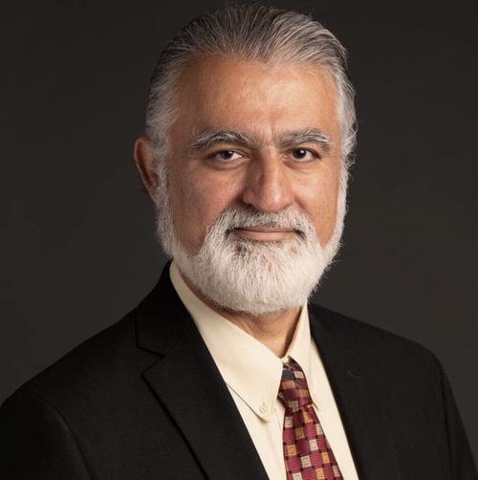




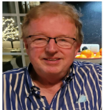


Top L to R: Dr. Farzam Kamalabadi - Chief Counsel to the Board(CCB); E. Lukomona (Germany) - Chairperson;
M. Branchetti - Vice Chairperson (Italy); His Royal Highness Chief Dr. Ishima Mwanta(Zambia) - Chiefdoms Development.

Bottom L to R: L.Kaila (Zambia) - Executive Director; Prof. Dr. E. Simukanzye(Zambia) - Training & Development;
T. Chileshe(Zambia) - Community Development; J. Thomnsen (Germmany) - Investor Relations; A.Tembo(Zambia) - Mining & Minerals Advisory(Zambia)

Not In Picture: Dr. C. Wintzer, Legal Advisory(Germany); E. Triboli (Germany) – Business Advisory.

BECOME A ZAMAP PARTNER
Download the Application Form:
https://www.central-international-university.org/de/ZAMAP-PRECIOUS-METALS/

In compliance with the relevant ministries and departments:

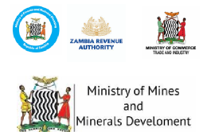

“Zambian Gold - Empowering You, Your Community, and the Nation.”

For more enquiries kindly write to:
The CEO’s Office
CDT Group Germany HQ
Email: el@central-international-university.org

