Top. L toR:
E. Lukomona (Germany), Chairperson; M. Branchetti Vice Chairperson(Italy); J. Thomnsen(Germmany, Investor Relations; Prof. Dr. E. Simukanzye(Zambia), Training & Development;

Bottom. L to R.
T. Chileshe(Zambia), Community Development; L.Kaila (Zambia), Executive Director; His Royal Highness Dr. Ishama Mwanta(Zambia), Chiefdoms Development; Dr. C. Wintzer, Legal Advisory(Germany); D. Kakusa(Zambia), Legal Advisory.

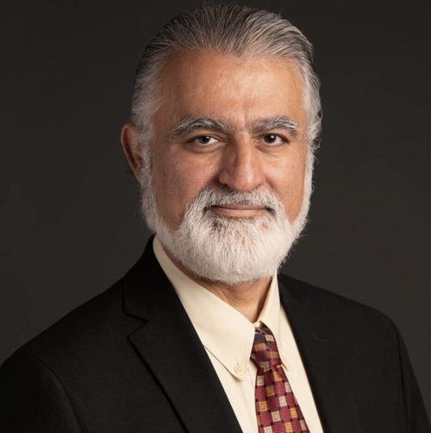

Dr. Farzam Kamalibadi, Chief Counsel to the Board(CCB)



